Virtual Assistant
Requirement Definition Document
Document Version 2.1 and Date 12 December 2018
By Avinash Gohil & Rajkumar Mehra
avinash.gohil@mastek.com
rajkumar.mastek@mastek.com

Distribution List
Sr. No. | Name
 | Creative Virtual Ltd.
 | Mastek Ltd.

AMENDMENT HISTORY
Version No. | Date | Prepared By /Modified By | Nature of Changes
0.1 | 16 April 2009 | Avinash Gohil  Rajkumar Mehra | Created
0.2 | 22 April 2009 | Avinash Gohil  Rajkumar Mehra | Updated based on review comments by Creative Virtual
0.3 | 22 April 2009 | Avinash Gohil  Rajkumar Mehra | Updated based on review comments by Creative Virtual
1.0 | 24 April 2009 | Avinash Gohil  Rajkumar Mehra | Updated the version number and modified elements to black colour, based on acceptance given by Creative Virtual
1.1 | 12 May 2009 | Avinash Gohil  Rajkumar Mehra | Updated the FAQ Handling use case, based on Peter’s comments.
1.2 | 18 June 2009 | Avinash Gohil  Rajkumar Mehra | Updated the comments sent by Peter
1.3 | 09 July 2009 | Avinash Gohil  Rajkumar Mehra | Updated the wordings on exclusions (from the work order).
2.0 | 17 July 2009 | Avinash Gohil  Rajkumar Mehra | Updated the version number, email id’s and modified elements to black colour, based on acceptance given by Creative Virtual
2.1 | 17 July 2009 | Avinash Gohil | Updated as per  - MOM’s at design phase  - Query log

Review Panel
Name | Role
Peter Behrend | CTO, Creative Virtual
Richard Mason | Technical Author, Creative Virtual
William Perkins | Technical Author, Creative Virtual

Reference Documents
Reference ID | Document Name | Document Version & Date
[R1] | Scripting reference.pdf | -
[R2] | Existing System Understanding.doc | v2.0, 14-Apr-2009
[R3] | Functional Specifications.doc | v0.2, 22-Apr-2009
[R4] | Queries.xls | 14-Apr-2009
[R5] | NLP Engine.pdf | -

Conventions Used To Highlight Changes To This Document

Text and the outer boundary of figures in the BROWN colour signify the updates done to this document from the previous released version.
Items deleted from previous released version of this document would be mentioned in the AMEDMENT HISTORY.

Table of contents

1 OVERVIEW 9
1.1 Introduction 9
1.1.1 Company‘s Background 9
1.1.2 Company’s Key Business Process 9
1.1.3 Company’s Organization Structure 10
1.1.4 Company Locations 10
1.1.5 History of Computerization 11
1.1.6 Status of Existing Computerization 11
1.1.7 Hardware & Software Platforms of Existing System 11
1.1.8 Hardware & Software Platforms for Proposed System 11
1.2 Objectives of Proposed System 11
1.2.1 Business Needs To Be Addressed 11
1.2.2 Critical Success Factors of the System 11
1.2.3 Constraints and Limiting Factors 11
1.2.4 Security & User Access Requirements 11
1.3 Scope 12
1.3.1 System Overview 12
1.3.2 Activities excluded/ to be taken up in later phases 13
2 SYSTEM CONCEPTS 14
2.1 System Features 14
2.1.1 User Interface Features 14
2.1.2 Security & User Access Features 14
2.1.3 Interfaces to Other Systems 14
2.1.4 Controls 15
2.1.5 Access Mechanism 15
3 GENERAL REQUIREMENTS 16
4 USE CASE WISE WORK-FLOW and Requirements 17
4.1 Use Case Diagram at a Glance 17
4.2 Use Case: Initialise Web Interface Server 18
4.2.1 Work-Flow Diagram 18
4.2.2 Operations 18
4.2.3 Inputs 18
4.2.4 Information Requirements 18
4.2.5 Critical Factors 18
4.2.6 Business Actors 18
4.2.7 Normal Flow 18
4.2.8 Output 18
4.3 Use Case: Initialise Virtual Assistant Server 19
4.3.1 Work-Flow Diagram 19
4.3.2 Operations 19
4.3.3 Inputs 19
4.3.4 Information Requirements 19
4.3.5 Critical Factors 20
4.3.6 Business Actors 20
4.3.7 Normal Flow 20
4.3.8 Output 20
4.4 Use Case: Load knowledgebase 21
4.4.1 Work-Flow Diagram 21
4.4.2 Operations 21
4.4.3 Inputs 21
4.4.4 Information Requirements 21
4.4.5 Critical Factors 23
4.4.6 Business Actors 23
4.4.7 Normal Flow 23
4.4.8 Output 23
4.5 Use Case: Send HTTP Request 24
4.5.1 Work-Flow Diagram 24
4.5.2 Operations 24
4.5.3 Inputs 24
4.5.4 Information Requirements 24
4.5.5 Business Actors 25
4.5.6 Normal Flow 25
4.5.7 Output 26
4.6 Use Case: Administrative Services 26
4.6.1 Work-Flow Diagram 26
4.6.2 Operations 26
4.6.3 Inputs 26
4.6.4 Information Requirements 26
4.6.5 Business Actors 29
4.6.6 Normal Flow 29
4.6.7 Output 29
4.7 Use Case: License Management 30
4.7.1 Work-Flow Diagram 30
4.7.2 Operations 30
4.7.3 Inputs 30
4.7.4 Information Requirements 30
4.7.5 Critical Factors 30
4.7.6 Business Actors 30
4.7.7 Normal Flow 30
4.7.8 Output 30
4.8 Use Case: Parse HTTP Request/ VA Interface 31
4.8.1 Work-Flow Diagram 31
4.8.2 Operations 31
4.8.3 Inputs 31
4.8.4 Information Requirements 31
4.8.5 Critical Factors 32
4.8.6 Business Actors 32
4.8.7 Normal Flow 32
4.8.8 Output 32
4.9 Use Case: Create Session/Session Management 33
4.9.1 Work-Flow Diagram 33
4.9.2 Operations 33
4.9.3 Inputs 33
4.9.4 Information Requirements 33
4.9.5 Critical Factors 34
4.9.6 Business Actors 34
4.9.7 Normal Flow 34
4.9.8 Output 34
4.10 Use Case: Process Request 35
4.10.1 Work-Flow Diagram 35
4.10.2 Operations 36
4.10.3 Inputs 36
4.10.4 Information Requirements 36
4.10.5 Business Actors 37
4.10.6 Normal Flow 37
4.10.7 Output 37
4.11 Use Case: Recognition Selection Process 38
4.11.1 Work-Flow Diagram 38
4.11.2 Operations 39
4.11.3 Inputs 39
4.11.4 Information Requirements 39
4.11.5 Business Actors 42
4.11.6 Normal Flow 42
4.11.7 Output 42
4.12 Use Case: Process Sentences 43
4.12.1 Work-Flow Diagram 43
4.12.2 Operations 43
4.12.3 Inputs 43
4.12.4 Information Requirements 44
4.12.5 Business Actors 44
4.12.6 Normal Flow 44
4.12.7 Output 44
4.13 Use Case: Determine Condition List 45
4.13.1 Work-Flow Diagram 45
4.13.2 Operations 45
4.13.3 Inputs 45
4.13.4 Information Requirements 46
4.13.5 Business Actors 46
4.13.6 Normal Flow 46
4.13.7 Output 46
4.14 Use Case: Answer Selection Process 47
4.14.1 Work-Flow Diagram 48
4.14.2 Operations 48
4.14.3 Inputs 48
4.14.4 Information Requirements 49
4.14.5 Business Actors 50
4.14.6 Normal Flow 50
4.14.7 Output 50
4.15 Use Case: Create Response 51
4.15.1 Work-Flow Diagram 51
4.15.2 Operations 51
4.15.3 Inputs 51
4.15.4 Information Requirements 51
4.15.5 Business Actors 52
4.15.6 Normal Flow 52
4.15.7 Output 53
4.16 Use Case: FAQ Handling 54
4.16.1 Work-Flow Diagram 54
4.16.2 Operations 54
4.16.3 Inputs 54
4.16.4 Information Requirements 54
4.16.5 Business Actors 55
4.16.6 Normal Flow 55
4.16.7 Output 55
4.17 Use Case: Write VA Conversation Statistics (BOTSTATS) 56
4.17.1 Work-Flow Diagram 56
4.17.2 Operations 56
4.17.3 Inputs 56
4.17.4 Information Requirements 56
4.17.5 Critical Factors 57
4.17.6 Business Actors 57
4.17.7 Normal Flow 57
4.17.8 Output 57
4.18 Use Case: Test V-Builder Knowledgebase 58
4.18.1 Work-Flow Diagram 58
4.18.2 Operations 58
4.18.3 Inputs 58
4.18.4 Information Requirements 58
4.18.5 Critical Factors 62
4.18.6 Business Actors 62
4.18.7 Normal Flow 62
4.18.8 Output 62
5 NON FUNCTIONAL REQUIREMENTS 63
6 ANNEXURE 66
6.1 Glossary of Terms 66
6.2 Abbreviations 66
6.3 Document Describing Process for Conditions with Rank 0 66

Table of Figures
Figure 1: Organisation Chart 11
Figure 2: System Context Diagram 14
Figure 3: Use Case Diagram at a Glance 19
Figure 4: Browser window as shown to an end user. 26
Figure 5: Login Screen 28
Figure 6: Administrator Control Panel 29
Figure 7: Work Flow – Process Request 37
Figure 8: Work Flow – Recognition Selection 40
Figure 9: Work Flow – Process Sentences 45
Figure 10: Work Flow – Determine Condition List 47
Figure 11: Work Flow – Answer Selection 50
Figure 12: Various components of FAQs 57

OVERVIEW

Introduction

Company‘s Background
Creative Virtual Ltd has over 15 years of experience working with Virtual Assistant natural language web applications. They operate mainly in UK and US. Their major clientele is Lloyds TSB, BT, BBC, Sharp electronics, Sky TV, National Rail Enquiries, and Philips etc.

Company’s Key Business Process
Creative Virtual’s implementation method consists of 4 phases:
- Quick Start
Using the Virtual Assistant as an Intelligent FAQ system including natural language recognition and links to appropriate web pages
- Rapid Update Cycle
Using the Virtual Assistant reporting tools (BotStats) to enhance the natural language recognition capabilities and FAQ’s
- Advanced Conversation and Integration
Development of conversational trees and full integration into the enterprise – by allowing Virtual Assistant to take a more sophisticated customer service and sales role
- Maintenance
Creative Virtual’s update process is flexible enough to fit in with our existing workflows and systems, keeping the maintenance lean and efficient.

Products
- Virtual Assistant
With Creative Virtual’s Virtual Assistant, customers receive friendly and competent service 24 hours a day, all year around. The Virtual Assistant answers questions in natural language, instantly giving customers the information they seek and for a fraction of the cost of a human customer services assistant.
The advantages of including a Virtual Assistant are numerous. A short list would include:
- Assisting in Web site navigation.
- Conducting e-commerce.
- Offering quick and efficient responses to customers' frequently asked questions.
- Providing entertaining and unique customer support.

Markets
- Financial Services
- Retail
- Tele-communications
- Health-care etc.

Customers
Following are some of the customers of Creative Virtual Ltd.
- British Telecom
- Lloyds TSB
- Alliance Leicester
- National Rail Enquiries
- Renault
- Waterstone's
- Philips
- BBC
- Cahoot
- Legal & General
- Novartis
- One Railway

Competitors
NA

Suppliers
NA

Company’s Organization Structure
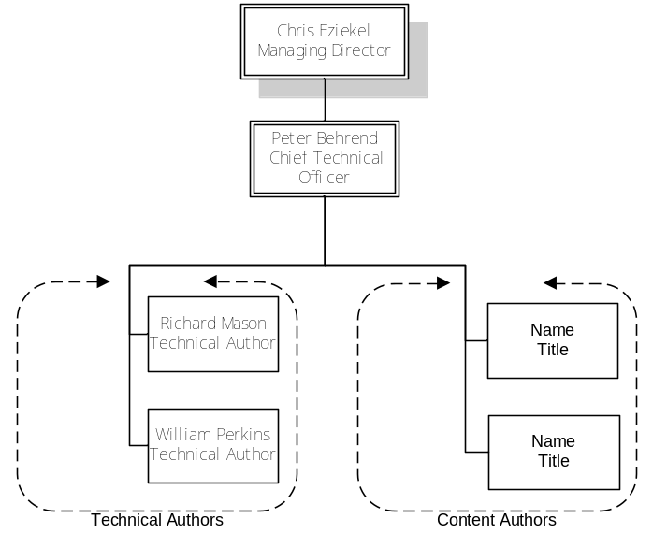
Figure 1: Organisation Chart

Company Locations
- Creative Virtual Ltd,
167 Cannon Workshops
5 Cannon Drive
London E14 4AS
- Creative Virtual
PO Box 492
Old Greenwich
CT 06870

History of Computerization
NA

Status of Existing Computerization
NA

Hardware & Software Platforms of Existing System
Production servers typically have the following configuration:
- Single 2.0 GHz+ CPU
- 2GB+ RAM (shared platform – up to 4 average trafficked; average content VAs).

Hardware & Software Platforms for Proposed System
Proposed Production servers should be similar to the ones already used, as described below:
- Single 2.0 GHz+ CPU
- 2GB+ RAM (shared platform – up to 4 average trafficked; average content VAs).
- Local test implementation should be able to run on lower-specified machine.

Objectives of Proposed System
The main objective of the proposed system is to rebuild the existing system from scratch. The main purpose of re-building the web engine is:
- Extensibility
- Performance
- Maintainability
The main purpose of re-building the V-Builder is:
- Improved Interface
- Usability and Navigability

Business Needs To Be Addressed
- Provide flexibility in adapting to new opportunities arising in the Virtual Assistant market space.
- Ability to create Virtual Assistants for languages other than English, there by providing an edge over competitors in the Virtual Assistant market space.

Critical Success Factors of the System
- Short response time (time to react to a given input)
- Usability

Constraints and Limiting Factors
The proposed hardware configuration maybe a limiting factor in achieving the desired timing related performance.

Security & User Access Requirements
- Web based user authentication for administrative role.
- Role-based user authentication in V-builder.

Scope
The Virtual Assistant consists of a rule-based artificial intelligence engine for engaging a natural language dialogue while keeping the context of conversation and an editor/builder for creating and updating the knowledge base.
The VA comprises of the following components:
- Artificial Intelligence Engine, for Natural Language Processing (NLP).
- Scripting Engine.
- V-Builder.

System Overview
A Virtual Assistant is a virtual personality that chats online with users. It recognizes and responds appropriately to natural language - that is, the way people talk. In addition to understanding natural language, a Virtual Assistant uses graphics to reveal emotions appropriate to the conversation. Virtual Assistants use kind of Artificial Intelligence Processes for the same.

Virtual Assistant’s have three essential elements: recognitions, answers and macros. Together they form a knowledge base which is used as a repository of inputs the VA shall understand and reply accordingly. The answers given by the Virtual Assistant relate mainly to the organization/product/service for which the Virtual Assistant is developed.

The existing Virtual Assistant system comprises mainly of 2 clearly identifiable sub-systems:
- Virtual Assistant Creator (V-Builder)
- Virtual Assistant Engine (Web-interface server and VA Engine), which contains the NLP.

Module-wise/Sub-system-wise Briefing
- Virtual Assistant Creator (V-Builder)
V-Builder is an UI application which is to be used for creating the knowledge base. This application provides functionalities to create recognitions, conditions associated with the recognitions, answers to be given when a recognition/condition matched with user’s input. It also provides functionalities to create scripts which have to be executed at various milestones in the NLP. Scripts are a very important part of the system as they bring in an element of flexibility into the entire process.
- Virtual Assistant Engine (Web-interface server and VA Engine), which contains the NLP.
The web-interface server and VA Engine are entrusted with the responsibility of interacting with the user. VA engine uses the knowledgebase to build up a vocabulary which is used to understand what the user is saying and then send an appropriate response. The VA engine also has functionalities to send answers in various formats as desired.

Context diagram
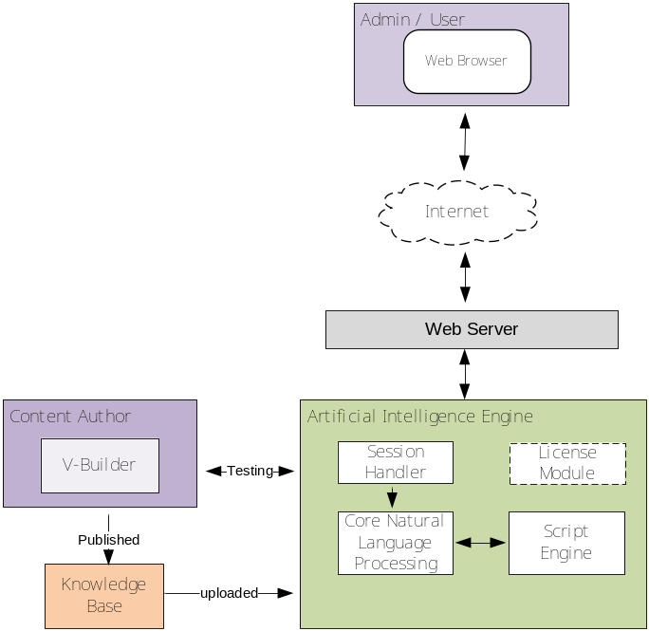
Figure 2: System Context Diagram

Activities excluded/ to be taken up in later phases
- Advanced centralised licence management in the context of V-Builder is excluded from current scope as the details are to be worked out.
- Concepts like advanced Decision Tree (D Tree) structure have been excluded from current scope as the details have to be worked out. However the system design has to be such that it has to be extensible to include this concept.
- Multiple Role based login for the V-Builder have been currently kept out of scope. Currently there have to be only 2 roles, ‘Administrator’ and ‘Content Author’.
- In the V-Builder, advanced concept like drag and drop of recognitions / conditions / answers / MACROs or any other element has been excluded from the current scope and shall be taken up in next phase(s).
- In the V-Builder, standard cut / copy / paste functionality for recognitions / conditions / answers / MACROs or any other element has been excluded from the current scope and shall be taken up in next phase(s). All text fields in the V-Builder should, however, support this functionality only for copying/cutting/pasting text entries.
- Functionality to provide Easter eggs in the V-Builder and the VA engine has been excluded from current scope and shall be taken up in later phase(s).
- The ability to bypass the recognition selection process and directly fetch an Answer which is “attached” to a Recognition will be supported in this phase in order to rationalise the operation of FAQ system. However, if in future phases the disconnection of Answers from Recognitions is implemented, then this will require a different method to be developed to return any (disconnected) Answer directly. The creation, maintenance and use of disconnected Answers within the V-Builder will also have to be addressed in the later phase.
- 64-bit support has been currently kept out of scope shall be taken up in later phase(s).
- Preparation of User manuals is out of scope.
- Possibility in future of returning more than one Answer for each user input.
- The migration of the following items from existing application to the new application is out of scope:
  - Data
  - Existing knowledgebase scripts and functions
  - Knowledgebases

SYSTEM CONCEPTS
This section covers the basic concepts, which are common across a system. The points under this head would translate into ‘design philosophy’ and ‘programming standards’ in the system design document.

System Features

User Interface Features
Following points need to be considered while designing the UI for V-Builder:
- Navigation
Develop a standard and uniform method for navigating through recognitions, conditions, macros and answers.
There is a need to provide 3 views of the knowledgebase:
Knowledgebase Explorer View – Should contain Tree structures for displaying groups/categories in various recognitions/answers and macros are stored.
Grid View – Should display all the recognitions/answers/macros for a particular group/category as selected in the Knowledgebase view.
Edit View – Should have a standard Tabbed structure for editing recognitions, conditions, answers and macros and setting various options for each of them as applicable.
- Forms
Develop a standard method for laying out and presenting information on forms, including methods of navigating between various parts of the form, standard colours for forms, and some of the basic functionality that should be built into all forms. E.g layout and position of the “Accept” and “Reject” buttons should be same through out.
V-Builder requirements are described in detail in the document Functional Specifications using snapshots of various screen/forms.

Security & User Access Features
- It is required to have the entire knowledgebase file stored in XML but in an encrypted format and with an extension not used by any standard, commercial or shareware or freeware, XML editor. This encrypted knowledgebase file should be read by only the V-Builder and the VA Engine and only the V-Builder should be able to edit it.
- It is required to provide Administrative role for controlling the VA engine, details of functionality to be provided for this role are described in the use case Administrative Service.
- In the V-Builder, it is required to provide 2 roles, ‘Administrator’ and ‘Content Author’. Restrictions on various screens for the content authors have been described in the document Functional Specifications.

Interfaces to Other Systems
All the applications i.e. the V-Builder, the web-interface or the VA engine interact only amongst themselves and there are no interactions with any other system.

Controls
NA

Access Mechanism
Please refer description for V-Builder access related requirements in the document Functional Specifications.

Authorization
NA
2.1.1.2 Integrity
Test cases should be specifically designed to ensure data integrity of the system. It is required to ensure that the recognitions/answers/MACROs/scripts/library functions and any related element(s) create using the V-Builder are saved in thee right intended manner and are used by the VA engine to display the right intended information to show to the user.
This will ensure integrity of data from the point of creation in the V-Builder to the point of being displayed to the user.

GENERAL REQUIREMENTS
Requirements of the V-Builder application, which is used to create the knowledgebase, are described in the document Function Specifications. This document captures B-Builder related requirements using proposed screen-shots of the application, describing the details of various fields/control present on each screen and action to be taken for each screen and in the background. This section describes general requirements in detail.
E-SRS [1]
- It is required that the application should be UNICODE compliant, all information stored in the knowledgebase should be in UNICODE format and it should be read and interpreted correctly by the VA engine.
E-SRS [2]
- Advanced scripting support is required to execute scripts in the system. Please refer Scripting reference for more details on the scripting support required.
E-SRS [3]
- It is required that the VA engine should support multiple languages. For this, the knowledge base can contain recognitions, answers and MACROs written in any language
- Assumption – During pattern matching process, words have to be auto-corrected for spelling mistakes and searching for keyboard proximity. This functionality would be language dependent. It would be developed only for English language and the algorithm for writing the same would be provided by Creative Virtual.
- All logs created by the engine shall be in English language only.
- It is required that the V-Builder should support multiple languages.
- For the V-Builder, it is required that the UI interface should also support multiple languages. For this support the V-Builder should read information such as the text on various labels, controls, etc. from a UI configuration file.
E-SRS [4]
- It is required to create help files for the V-Builder in HTML/CHM format. Help files shall be created in English language only.
E-SRS [5]
- It is required that the VA engine have a inbuilt logging facility for logging messages, warnings, errors and fatal errors.
- This logging mechanism should be enabled/disabled with the help of compile time switches only.
- The messages, warnings, error messages, fatal error messages shall be logged in English language only.
E-SRS [6]
- It is required that the VA engine should provide a functionality whereby the engine and/or the scripts can set cookies on the users machine. The engine should only provide a mechanism for getting data related to cookies and pass it on to the scripts, on request. It should not set cookies; cookies are only to be set by scripts.

USE CASE WISE WORK-FLOW and Requirements
To understand the functional requirements of the proposed Virtual Assistant engine, several use cases have been identified. These use cases describe the actions that are crucial for the functioning of the NLP.

Use Case Diagram at a Glance
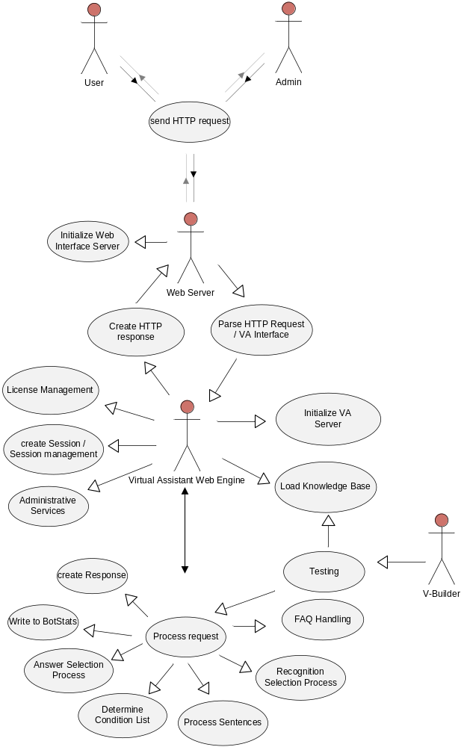
Figure 3: Use Case Diagram at a Glance

Use Case: Initialise Web Interface Server
The web server is the point of entry for all types of requests sent to the VA engine. The VA engine is completely dependent on the Web server for it’s communication with any type of user. In the current system this responsibility rests with the CGI-Adapter. Please refer section 5 of Existing System Understanding for more details of current system architecture. For the new requirements this module/application is being called as the Web Interface Server to include all terms like a web server (IIS, Apache Tomcat), CGI adapter, a servlet, a JSP/ASP page, etc. This use case describes the requirements for initialising the web interface server.

Work-Flow Diagram
N/A

Operations
NA

Inputs
NA

Information Requirements
E-SRS [7]
- The web interface server should include all the standard features available in a standard commercially available web server like Microsoft IIS, Tomcat Apache, Web-sphere, etc.
- The web interface server should be scalable in terms of number of users and types of functionalities.
E-SRS [8]
Following activities should be carried out when the web interface server is executed:
- It should load a configuration file which should contain the following details:
- URLs to be shown to the user when the VA is closed, shutdown, unavailable and busy.
- Connection information specific to the VA, i.e. the IP address and port number at which the VA engine shall be listening to requests sent by the web interface server.
- For all request modes, load a list of IP addresses to be denied/allowed.
- It should set up a HTTP server and establish connection with the VA engine using the connection information from the configuration file.

Critical Factors
NA

Business Actors
NA

Normal Flow
NA

Output
NA

Use Case: Initialise Virtual Assistant Server
The Virtual Assistant (VA) server has the main responsibility of performing tasks related to Natural Language Processing (NLP). The VA server also has to listen over a TCP/IP port to accept user requests sent to it by the web interface server and transmit back responses to the same.
This use case describes the initialisation process of the VA server/engine.

Work-Flow Diagram
N/A

Operations
NA

Inputs
Configuration File.

Information Requirements
E-SRS [9]
- When started, the VA engine should load the configuration file, which should contain details like:
- TCP/IP port at which it should receive user inputs and transmit replies.
- Fully qualified File name of the knowledgebase file, which should be loaded into memory as described in the use case Load Knowledgebase.
- Fully qualified path of the folder in which the templates are stored.
- Fully qualified path of the folder where images related to emotions are stored.
- Session time out in seconds.
- Email address where daily mail transcripts have to be sent.
- Details of the SMTP server to be used for sending emails during NLP.
E-SRS [10]
  - After loading the configuration file, the engine should load the knowledgebase into memory by invoking the use case Load Knowledgebase.
E-SRS [11]
- After successfully loading the knowledgebase, it should initialise the scripting engine. This module shall execute various scripts like Recognition Scripts, Answer Scripts, Global and System scripts, as and when required. For details on requirements of a scripting engine, please refer document Scripting reference.
E-SRS [12]
  - Next it should load and initialise the Licensing module, which shall be used by the use case License Management.
E-SRS [13]
  - After loading the license management module, it should load and initialise the session management module, to be used in the use case Create Session/Session Management.
  - The session time out loaded from the configuration file should be passed on to this module.
E-SRS [14]
  - The engine should spawn a thread which should iterate through all recognition/conditions and answers on a periodic basis, the period should be configurable, and search for the active status of the same.
  - Each recognition, contained conditions and answers can be assigned dates from which they are to become valid and the date until which they should remain valid. Please refer Functional Specifications for more details.
  - If this thread finds that any condition or answer is not to be activated it should set a flag in that particular condition/answer so that it is not used in the recognition selection and the answer selection process respectively.
E-SRS [15]
  - Finally, the engine should set up a TCP/IP listener at the port specified in the configuration file and start the VA server.

Critical Factors
NA

Business Actors
NA

Normal Flow
NA

Output
NA

Use Case: Load knowledgebase

Work-Flow Diagram
NA

Operations
This use case loads knowledgebase, answer table, abbreviation and auto-correction data, templates and configuration files in the memory as a part of initialisation process.

Inputs
- Knowledgebase file
- Table Answer files
- Abbreviation file
- Auto-correction file
- Configuration files
- Templates

Information Requirements
E-SRS [16]
It is required that a knowledgebase file should be loaded at the time of engine start-up i.e. as an initialisation process.
The knowledgebase file consists of following items:
- Recognitions , associated conditions and scripts
- Answers, associated additional condition, scripts, table answers and other answer options
- MACROS
- Global Scripts, System Scripts and Script functions.
For details on creating the above mentioned artefacts, please refer the Functional Specification.
When a knowledgebase is loaded into VA engine’s memory, each of the above mentioned artefacts is loaded from the knowledgebase file and associated with each other.
E-SRS [17]
- All MACROs present in the knowledge base should be loaded into memory and stored in a Macro list.
- For each MACRO a Macro condition tree should be created and this should be stored in the MACRO list for reference in the NLP.
E-SRS [18]
- All System and Global scripts present in the knowledgebase should be read and stored in memory for execution at the right point in the NLP.
E-SRS [19]
- All Library functions should be loaded into memory for execution by the scripts/VA engine at the right point in the NLP.
E-SRS [20]
- All recognitions present in the knowledgebase should be loaded into memory and stored in a list. A recognition contains references to it’s condition(s), answers and recognition scripts.
E-SRS [21]
- It is required that all conditions associated with all recognition in the knowledgebase be loaded in a single condition list. This can be called as the main/master condition list. For details on the various conditions and operators possible with conditions, please refer section 5.2 of the document Existing System Understanding.
- Conditions are stored in the knowledgebase in the form of condition strings. To make more meaning out of them, they have to be parsed and stored in the form of a condition tree which can be tested at run time when any user input comes in. For details on the structure of a condition tree, how a condition string is parsed into a condition tree and how a condition tree is stored in memory, please refer sections 5.2.1 and 7.4 in the document Existing System Understanding.
- While creating the condition list, the order of storing the conditions in the list is based on the rank of the condition. A condition with lower rank number should be store before a condition with higher rank number.
E-SRS [22]
- It is required to categorize conditions in the main/master list based on the sections a condition is assigned to in the v-Builder application. For details in setting sections to any condition, please refer Function Specifications.
- At the time of loading the knowledgebase, the VA engine should also determine the number of sections present in the knowledgebase, and on the basis of that, it should create a list for each section.
- Each section list should contain references to the conditions that refer to the section.
- To do the same, after all conditions are loaded into memory, the main/master condition list should be iterated and each condition should be checked if it belongs to any section(s).
- If any condition is associated with 1 or more section(s), it’s reference should be added to the respective list.
E-SRS [23]
- All answers present in the knowledgebase should be loaded into memory and stored in a list. Each answer has to be associated with it’s parent recognition. An answer contains references to it’s text, expected responses answer numbers, topics, additional condition, table answers, email options, templates, extra template variables and answer scripts.
E-SRS [24]
- If a table answer file is associated with any of the answers in the system, it is required that a table answer file be parsed and read in memory at the time of engine start-up. It maybe possible that there are no table answers in the knowledgebase.
- This file is a delimited text file from which multiple answers may be generated. The fields may be separated by a delimiter e.g. tab, #, comma etc.
- Each table answer file should be loaded into memory as a list, with the 1st column in the table answer being the key. Data present in the 1st column, i.e. they key should be treated as like a condition string representing the additional condition for that particular answer in the answer table. The value part should be all other columns present in that row of the table answer file.
- If a table answer file appears in the data part of more than one answer, a common table should be created and all such answers should refer to it.
- The first column of this text file becomes an additional condition for the answer associated with this table answers file. It is designated by V-Builder as _ta_fieldValue[0], followed by _ta_fieldValue[1] and so on. Please refer Existing System Understanding and Function Specifications for more details.
- Both the condition and _ta_fieldValue[0] should match the user input for an Answer to be returned from _ta_fieldValue[1] in the same row. Table answers are used in the answer selection use case to check if any answer has a table answer and match additional conditions from the table.
E-SRS [25]
- It is required that the VA engine creates and maintains a list of words it understands, i.e. it’s vocabulary.
- To do the same, while parsing the conditions and MACROS, each word should be added to a wordlist. If a word has already been added to the wordlist, it should not be added again.
- The wordlist should be a kind of name-id container, which holds unique words with corresponding unique ID’s.
- These key/value pairs are to be referenced during the recognition selection process in the NLP.
E-SRS [26]
- It is required that an auto-correction and abbreviation file be parsed and read in memory at the time of engine start-up. This data should be used during sentence processing as a part of normalization of user input words.
E-SRS [27]
- It is required that the template files should be loaded into memory for use in the answer creation process before giving an answer to the user.
E-SRS [28]
- It is required that al the Extra Template Variables should be loaded into memory and stored in a name-value pair kind of container.
E-SRS [29]
  - On loading the knowledgebase, subsequently, a system script “OnKnowledgebaseLoaded” should be executed.

Critical Factors
N/A

Business Actors
N/A

Normal Flow
N/A

Output
All the various items like knowledgebase and configuration files are parsed and loaded in memory.

Use Case: Send HTTP Request

Work-Flow Diagram
NA

Operations
This use case begins with collecting the input data from the browser and completes with sending the same to the VA engine.

Inputs
NA

Information Requirements
E-SRS [30]
- It is required to send to the engine information about the user’s browser detail such as:
- Browser type.
- Cookies enabled/disabled status in the browser.
- JavaScript enabled/disabled status in the browser.
User interaction should be sent to the VA engine in any of the following request modes:
E-SRS [31]:
- NORMAL mode: This is the mode which be used by the end user of the system. When the user opens up the VA for conversation a browser window similar to the one below should be shown to the user:
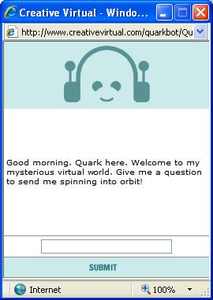
Figure 4: Browser window as shown to an end user.
- It is required that when the user writes anything into the text box and clicks on the button “Submit” the engine should be notified that an end user is trying to have a conversation, by using the NORMAL keyword in the HTTP request. Please note that the NORMAL is the default mode, hence, if no request mode is specified, the request mode should be assumed to be of type NORMAL.
- Details for handling this request type are described in the normal mode handling description of use case Parse HTTP request.
E-SRS [32]:
- STATE mode: This mode is not available to any end user and is a special mode used by the special users or power users of the system.
- This request mode is required to display user the following VA statistics:
  - Number of Licenses.
  - Number of users currently connected.
  - Number of admin and normal sessions currently active.
  - State of the VA – open or closed.
  - Software version, release version, build number and date
  - Knowledgebase Version
- It is required to have special web-addresses with should contain the keyword STATE to notify the engine that it’s statistics are being queried for.
E-SRS [33]:
- ADMIN mode: This request mode is required to service only administrators. It is required that an Admin page should be shown to the administrator. For the details of the services provided by the engine to an admin please refer use case Administrative Services.
E-SRS [34]:
- TRIGGER / SYSTEM mode: This mode is available only to the Administrators of the VA.
- The Administrator should be provided a mechanism whereby the keyword “TRIGGER” is sent to the engine using HTTP parameters.
Apart for these modes, the user interaction related to FAQs should be sent to the VA Engine using Form Variables, using FAQ as a parameter and value as the requested FAQ number.
E-SRS [35]:
- FAQ parameter: This mode is required to separate the handling of user inputs from user selection of FAQs.
- Details for handling this request type are described in the FAQ parameter handling description of use case Parse HTTP request.
- When a user clicks/selects any FAQ item the keyword FAQ should be sent to the engine along with the FAQ/answer number, via FORM variables.
E-SRS [36]:
- TEST mode: This should be similar to the NORMAL mode except it skips license check. It is required to have a user restriction on the basis of IP address i.e. The IP addresses of the allowed users should be placed in the ‘access.xml’ access rights file. By default, 5 test sessions should be allowed and it needs to be configurable.

Business Actors
End-User, Administrator

Normal Flow
N/A

Output
A HTTP request (query string) sent to web server.

Use Case: Administrative Services

Work-Flow Diagram
NA

Operations
This use case begins with getting the admin request from the browser and completes with performing a specified action in the engine. All the administrative services are carried out in ADMIN mode.

Inputs
NA

Information Requirements
E-SRS [37]:
- For an administrator, authentication mechanism is required, wherein an admin user has to enter a username and password and login into the system. The proposed login screen is as follows:
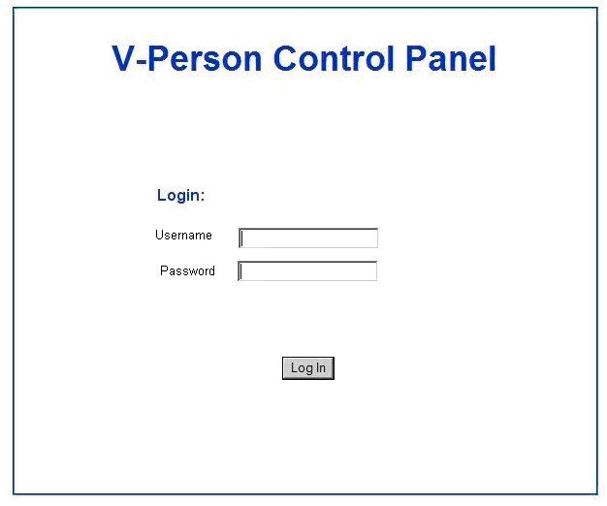
Figure 5: Login Screen
- The proposed Admin Control should be as shown below:
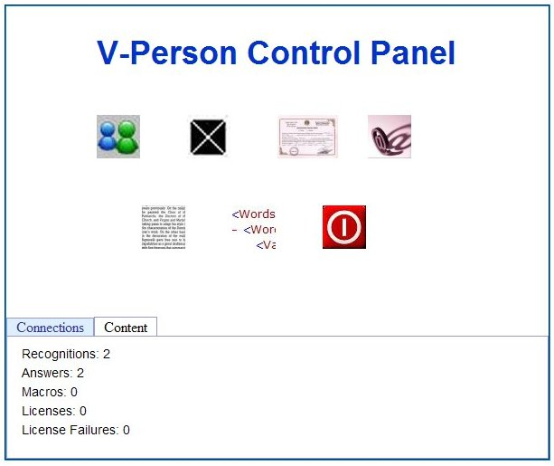
Shutdown VA
Reload KB
Reload Templates
Email
License
Close VA
Test VA
Figure 6: Administrator Control Panel
- As shown above, the page to be displayed to the Admin should have icons for carrying out various functionalities and should also have 2 tabs at the bottom for showing statistical data.
E-SRS [38]
The first tab “Connection” should display the following information:
- Active Connections: The total number of live normal sessions.
- User Connections: The total number of successful user sessions.
- Admin Connections: The total number of live admin sessions.
- Blocked Connections: It corresponds to incremental counter for blocked users due to insufficient licenses. The value is reset when VA is shutdown. (License Failure)
- Successful Admin Logins: The total number of successful logins.
- VA State: It corresponds to two VA states viz. Open or Close.
- Server ID: It corresponds to the MAC address of the network card and/or other hardware information on which this instance of the server will be deployed.
- Total Valid Licenses: It corresponds to the total number of valid licenses for VA.
E-SRS [39]
The second tab “Content” should display following information:
- KB version info: It should display the name and version number of knowledge base published on the VA
- VA version info: It should display the version number and release date of the Engine.
- Number of Recognitions
- Number of Answers
- Number of Macros
- Number of Inactive Recognitions
- Number of Inactive Answers
- Number of Conditions
E-SRS [40]
- It is required that more than one administrator should be allowed to login the system.

Various functionalities to be provided to the Administrator are described below:
E-SRS [41]:
  - Close VA: Selecting this option should
  - allow the admin to close the normal VA sessions. VA test sessions should not be affected by this action. When the VA is closed, following new functions should become available.
  - When it has been closed, the VA shall turn down all NORMAL mode requests and the user should be directed to a closed-URL.
E-SRS [42]:
  - Open VA: This option should be available only if the VA has been closed by an Admin.
  - On selecting this option the Admin asks the VA to start acting on NORMAL mode requests again.
E-SRS [43]:
  - Reload VA: This option should be available only if the VA has been closed by an Admin.
  - On selecting this option, the Admin asks the VA to unload the existing knowledgebase, save all session related data, if any, save any statistical data and then reload the knowledgebase, configuration, and template files to start afresh.
E-SRS [44]:
  - Reload VA Knowledgebase: This option works even when the VA is open.
  - On selecting this option, it is required that the VA should reload the knowledgebase.
  - This command should not interrupt current normal sessions. Therefore, current conversations / dialogs should be continued with the already loaded knowledgebase. The old knowledgebase will not be unloaded until all old sessions have expired.
  - However, any new sessions after re-loading of the knowledgebase should be conducted with the newly loaded knowledgebase.
E-SRS [45]:
  - Logoff: It should end the admin session. This shouldn’t have any influence on normal sessions.
E-SRS [46]:
  - Reload VA templates: It should reload template files without stopping the web server. It should check the templates and emotions sections of the server configuration file before executing.
E-SRS [47]:
This feature shall be detailed in the future along with the use case License Management. This requirement is being detailed here only for the sake of providing an example.
  - New VA license: The License number is generated manually using License Generator by the administrator. The details required for creating License number are as follows:
- Server ID: This is taken from the admin page.
- Absolute Path + filename of engine.exe: This is necessary to prevent the usage of same license key for multiple VA’s on the same server.
- No of Users: Known to the administrator
- Expiry Date: Known to the administrator
With the above details, License Generator generates a license key and this key is entered manually in engine configuration file i.e. engine.xml.
On click of New VA license, engine.xml is reloaded, and this key is checked by license manager for authenticity. The same algorithm is used by License generator and Engine.
If the check fails, then the key is invalid.
E-SRS [48]:
  - Shutdown VA: This should bring the engine (*.exe) down for updating a knowledgebase.
  - It is required that the engine is started at http request, if already not started.

Business Actors
Administrator, Engine

Normal Flow
N/A

Output
N/A

Use Case: License Management
To be decided.

Work-Flow Diagram

Operations

Inputs

Information Requirements

Critical Factors

Business Actors

Normal Flow

Output

Use Case: Parse HTTP Request/ VA Interface
Request sent to the VA has to be handled based on the type of request mode sent to it, as described in the use case Send HTTP Request. This use case describes the requirements for handling various types of modes and the processing associated with them.

Work-Flow Diagram
N/A

Operations
This use case begins with parsing a form data and completes with sending the engine the information in a XML format.

Inputs
HTTP request, containing keywords for various request modes and HTTP headers.

Information Requirements
E-SRS [49]
- Any HTTP request sent to the VA has to be handled 1st by a web adapter/web server (currently CGI adapter). This step is necessary so that the HTTP parameters are read and interpreted and then sent to the VA engine in a different format. Please refer the use case Parse HTTP Request in the document, Existing system Understanding for details on the mechanism used in the current system for sending data from the CGI adapter to the VA engine.
- This step is necessary so that the VA engine is not bothered with functionalities related to a web-server or HTTP parameter handling
Actions to be performed when the request modes are sent to the VA engine after being extracted from HTTP parameters are described below:
E-SRS [50]
- NORMAL mode: Normal mode is required to service the end-users using a normal conversation flow.
- On receiving normal request mode, the engine should determine whether this user is a new one or has been conversing with it earlier, in it’s lifetime. To perform this task the use case Create Session/Session Management should be invoked.
- Based on the result of the use case Create Session/Session Management, if the user request can be serviced at this point of time, the engine should invoke the use case Process Request.
- If the Create Session/Session management does not return success value, it means the VA does not have sufficient licenses available with which to begin conversation. In this case, a busy page URL is to be shown to the user.
- It is required to have a new form variable GACTION and an associated script OnGlobalTrigger. On receiving the form variable GACTION, the VA Engine should execute the script OnGlobalTrigger, this script should be executed in global/session scope and should have access to all system/global variables.
E-SRS [51]
- ADMIN mode: On receiving this request mode the engine should perform tasks as described in the Admin request mode.
E-SRS [52]
- TRIGGER mode: When the VA receives Trigger request it should execute the system script “On Trigger”.
- The script should have a return mechanism. (Currently the script does not return anything.)
E-SRS [53]
- STATE mode: When the VA receives the state request it should send the statistics as described in the State request mode.
E-SRS [54]
- FAQ parameter in Form Variables: When the VA receives the Trigger request it should invoke the use case FAQ handling.

Critical Factors
N/A

Business Actors
Web Server

Normal Flow
Examines the request, determines what kind of session should be created / fetched, selects the appropriate session type, and then invokes the particular session. It provides methods for setting cookies, sending email and reloading various items which are held in memory during normal program operation.

Output
Query re-directed to the Engine.

Use Case: Create Session/Session Management

Work-Flow Diagram

Operations
A session is the period of time from when the user first connects with a VA published on a server until the time that the user’s connection with the VA’s server is broken. Depending upon the session type different kind of sessions are created:
- The purpose of Normal Session is to provide a way to identify a user across one or more exchanges with the VA and to store conversational information pertaining to that user.
- The purpose of Admin Session is to provide a way to identify an administrator across one or more exchanges with the VA engine and to provide the facility to perform administrative tasks such as reloading the knowledge or configuration files.
- The purpose of State Session is to establish and maintain a session between the VA and a load balancer. Upon reacting, the State session renders a response containing basic license information and usage statistics.

Inputs
Request mode type and session id (optional).

Information Requirements
E-SRS [55]
For a NORMAL mode user, it is required that a session should store information about the user such as the following:
- Conversation time.
- Active Topic List
- Conversation history in the form of recognition/condition numbers and given answer numbers
- Unique Id associated with this session – the SessionID
- Global Script variable space
E-SRS [56]
- For handling sessions related to NORMAL request mode, it is required that the Session Manager maintain session details in 2 lists:
- Currently Active Sessions – this list should contain session ids/references of session for normal users which are currently “talking” with the VA engine.
- Expired Sessions – this list should contain session ids for the sessions that have expired i.e. they have timed-out as the user did not carry put any interaction for a specified amount of time.
E-SRS [57]
- On receiving a NORMAL request mode the engine should determine if the request has come from an existing user, a timed-out user or a new user.
- If there is no session id associated with this request mode, it is to be treated as a new user request. The use case should check if sufficient licences are available to allow conversation with the user. The use case License Management should be invoked for the same. If the Licence Management use case does not return success, this use case should also return a non success value and it should terminate. If the License Management returns success, a new session id should be created and the use case should terminate with a success value.
- If there is a session id associated with the request mode, the engine should 1st check in the active session list, if the session id associated with this request is present in the list, the use case should return with a success value.
- In case the user is not found in the active session list, the engine should search in the expired session list. If the session id associated with this request is present in this list, the use case should check if sufficient licences are available to allow conversation with the user. The use case License Management should be invoked for the same. If the Licence Management use case does not return success, this use case should also return a non success value. If the License Management returns success, the use case should terminate with a success value.
- In case the session id is not found any of the lists, it should be treated as a new user and the use case should check if sufficient licences are available to allow conversation with the user. The use case License Management should be invoked for the same. If the Licence Management use case does not return success, this use case should also return a non success value. If the License Management returns success, the use case should terminate with a success value.
E-SRS [58]
- On receiving the ADMIN mode request, the engine should create an Admin session for an administrator.
- This session should handle admin user authentication and invoke the administrative actions like reloading the knowledgebase or configuration files using web interface.
E-SRS [59]
- On receiving a State request, the engine should provide the facility to view statistics and basic information.

Critical Factors
N/A

Business Actors
VA Handler

Normal Flow
N/A

Output
N/A

Use Case: Process Request
This use case captures the requirement of the VA engine after the input has been identified as a NORMAL user input, by the VA handler, and is sent to the engine for NLP.
E-SRS [60]
This use case aims to capture the requirement of a “controller” for invoking other use cases for performing NLP.

Work-Flow Diagram
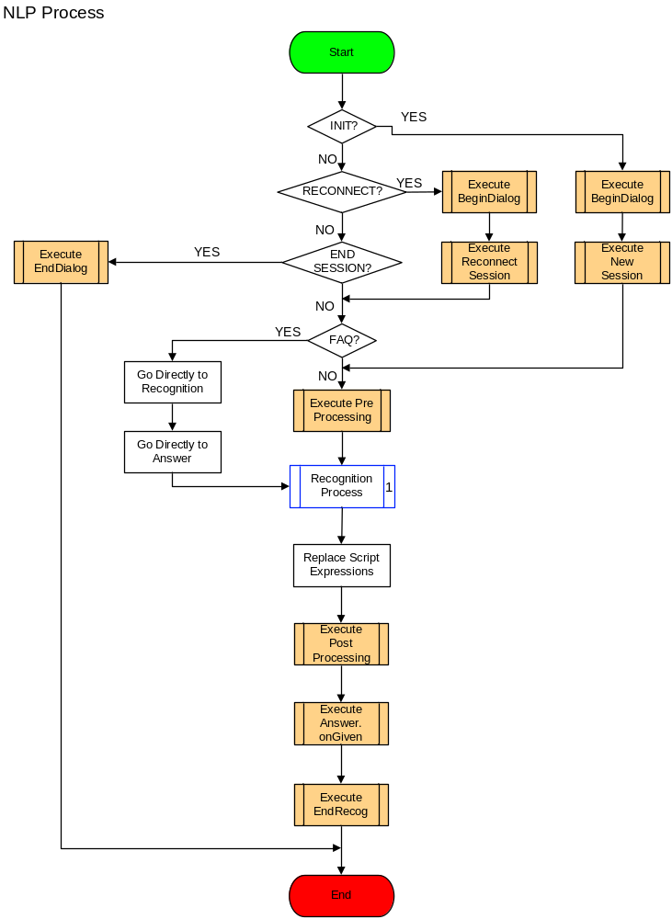
Figure 7: Work Flow – Process Request

Operations

Inputs
User input sentences(s).

Information Requirements
E-SRS [61]
- On receiving user input, the engine should determine whether this user is a new one or has been conversing with it earlier, in it’s lifetime.
- For this requirement, the engine should store user related information in the form of sessions. The engine should maintain a list of currently active sessions and expired sessions. If any user does not “talk” with the engine for a specified amount of time, the session time out, it’s sessions details are removed from the active session list and logged for further use. The session id is then stored in the expired session list. Please refer use case Session Management for details.
E-SRS [62]
- In case the user is a new one, the VA engine should execute the Global scripts BeginDialog and NewSession, in this order, in the same thread of execution.
- In case the user has come back again, the Global scripts BeginDialog and ReconnectSession, in this order, in the same thread of execution.
E-SRS [63]
- If the user has clicked on any of the FAQ items in the browser, the request should be sent to the user in NORMAL mode, but having form parameters specifying that it is a FAQ item. If this is the case for this input, then further processing should not be carried out in this use case and the use case Recognition Selection Use Case should be invoked from the point where the script OnChosen is to be executed.
- In the next step towards NLP, the VA engine should execute the global script Preprocessing.
E-SRS [64]
- After executing the script the VA engine should invoke the use case Recognition Selection Process.
E-SRS [65]
- Recognition selection process shall return one answer for user input. To create the answer using the correct type of template and also to replace any script expressions present in the answer text, the engine should invoke the use case Create Response.
E-SRS [66]
- After creating the answer, the VA engine should execute the Global PostProcessing script to carry out any post processing on the answer.
E-SRS [67]
- After creating the answer, the VA engine should execute the OnGiven script for that particular Answer to carry activities specific to the particular answer that shall be given to user.
E-SRS [68]
- After creating and sending the answer to the user, the VA engine should execute the Global script EndRecognition.
- Execution of this script indicates that an answer has been sent to the user, kind of a milestone in the NLP.
- Before this use case returns, the details such as user input, VA response, etc, should be written in a statistical file called as the BOTSTATS. For this, the use case Write BOTSTATS should be invoked.

Business Actors
Engine

Normal Flow
NA

Output
VA’s response to user input.

Use Case: Recognition Selection Process

Work-Flow Diagram
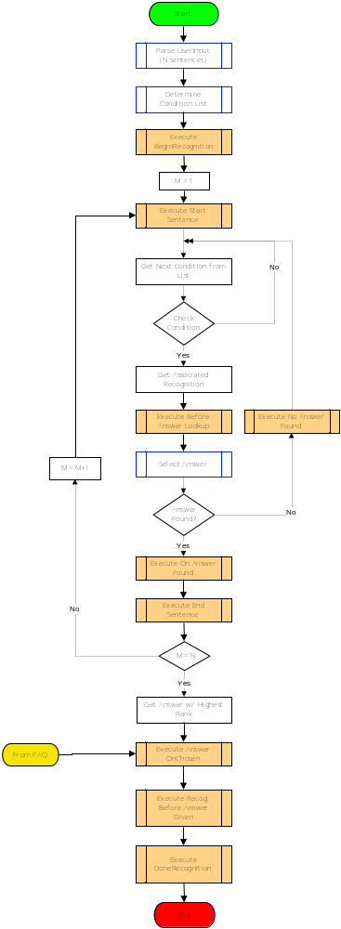
Figure 8: Work Flow – Recognition Selection

Operations

Inputs
User input on which pre-processing, if an, has been performed.

Information Requirements
E-SRS [69]
- Before going any further in NLP, user input has to be scanned to check for multiple sentences and if there are multiple sentences, they should be split into an array of sentences, for easy processing. This is required as the conditions are written on the basis of a sentence.
- For each sentence in the user input, 3 containers/lists should be created for NLP.
- To split sentences in user input and create these 3 containers, the use case Process Sentences should be invoked.
E-SRS [70]
- After getting the array of sentences, the engine should determine which condition list should be used for matching the sentences. To do this the use case Determine Condition List should be invoked.
- The basis of determining which condition list to use depends on the section in which a content author might have added the condition to. Sections are set with the help of scripts.
E-SRS [71]
- The next step in NLP should be to execute the global script BeginRecognition.
- Execution of this script indicates that the recognition process has started, kind of a milestone in the NLP.
E-SRS [72]
- For each sentence in the array the engine should carry out the following steps:
E-SRS [73]
- Execute the global script SentenceStart. This script can be used by the authors to keep track of the sentences processed by the engine. Of the number of sentences in an input, so on and so forth.
E-SRS [74]
- Using the condition list identified in the use case Determine Condition List, the engine should iterate through the list and pass the user input to each condition.
- It is required that for conditions with rank 0 (zero), no answer should be given to the user, however, specified answer scripts have to be executed as described in detail in the document describing the process for conditions having rank 0. As no answer is to be given, after executing the specified scripts, iteration has to proceed to the next condition in the list.
E-SRS [75]
- Each condition should be checked whether it is valid on the day of execution or not. If the condition has expired or is yet to become available, iteration should continue to the next condition in the list. A recognition can be set a “Valid From” and “Valid Until” dates from the V-Builder application and sue to this all the contained conditions also get this property. Please refer Functional Specifications for more details.
E-SRS [76]
- Each condition to which the input is passed should try to match the input string with it’s internal condition string, built up as a condition tree. For details on the structure of a condition tree, how a condition string is parsed into a condition tree and how a condition tree is stored in memory, please refer sections 5.2.1 and 7.4 in the document Existing System Understanding.
- To test the condition, the condition tree has to be traversed based on the type of condition at the root.
- The main root condition should pass on the input string and start and end positions to it’s contained conditions for testing. Each condition should perform the same task, i.e. pass on the input string with start and end position to it’s contained condition.
- When control reaches the final leaf condition, which generally should be a word or a Macro, it should test whether the word/macro is present in the input string at/between the start and end positions passed to it. In case a match is found that particular condition satisfies to be true.
- Control is then returned to it’s parent condition which shall be true/false depending on the result returned by these conditions. This continues till control reaches the main root condition and the final true/false result should be known, i.e. whether the condition matched the input string or no.
E-SRS [77]
- It is required that the engine maintain a table of tested Macros to improve timing performance.
- The table should be cleared every time a new sentence is taken up for recognition.
- The table structure should be as shown below, with example of macro SMALLTALK:
Macro Name | Start Position | End Position | Result
SMALLTALK | 0 | 4 | true
SMALLTALK | 1 | 3 | false
…
…

- Start Position and End Position are the positions at which the Macro has been tested once, Result shows whether the macro was found at/between these positions or not.
- When checking for a particular sentence, this table should be referred to every time a MACRO (e.g. SMALLTALK) occurs in a condition tree.
- If the positions passed to the macro are same as the ones present in the table, the macro should not be evaluated again, as the result for testing the macro between these positions is already known to be true/false.
- If the MACRO does not exist in the table, it should be added for future reference.
- This shall result in time saving as the macro may contain a lot of word/conditions/macros which would have to be evaluated every time, if such a table would not have existed.
E-SRS [78]
- It is required that for each MACRO that is tested in any condition tested from the main/master list of conditions, a check should be made for existence of the Normalised MACRO variable associated with that particular MACRO. If that MACRO tests successful the Normalised Macro variable value should be set to a system/global script variable whose name shall be given as the Normalised MACRO variable name. This is to be done only if the overall condition also returns true.
E-SRS [79]
- If a condition in the condition tree returns false, the engine should evaluate the next condition in the list for a match with the sentence and the entire process should repeat till a match is found or the list is exhausted.
E-SRS [80]
- If a condition in the condition tree returns true, the engine should get the associated recognition and should execute the recognition script BeforeAnswerLookUp, associated with this recognition.
- Thereafter it should invoke the use case - answer selection to get the answer from this recognition.
E-SRS [81]
- If a the use case - answer selection could not find an appropriate answer, the engine should start testing conditions, from the condition that was next to this one, for any other condition that would match this sentence.
E-SRS [82]
- In case an answer is found, or even if an answer is not found but the list of conditions is exhausted, the engine should execute the global script SentenceEnd.
- The execution of this script is kind of a milestone to indicate that processing for a sentence has completed.
E-SRS [83]
- In case an answer is not found, the engine should execute the recognition script OnNoAnswerFound for this particular recognition.
- If the section type is "Section + all" and no Answer has been selected for the current Section check then the complete Condition list should be checked, ignoring those which belong to the current Section and have therefore already been checked.
- In case an answer is found that suits the input sentence, the engine should execute the recognition script OnAnswerFound.
- Thereafter the engine should repeat the recognition selection for the next sentence.
E-SRS [84]
- On completing the recognition selection process for all the sentences in the input, the engine should check the answers got for each of the sentence and select only one of them.
- To do this the engine should select the answer whose recognition/condition has the highest rank among all the recognition/conditions that matched.
- For e.g. if the user has typed in 3 sentences, the recognition selection process found 3 conditions that matched each of the sentence and say it got 3 answers from the associated recognitions of ranks 4/10, 1/2 and 1/10. Please note that even though any recognition can have more than 1 answer, the use case select answer should return only 1 out of them based on answer selection criteria. The engine will select the answer whose recognition has the highest rank, in this case the one with rank 1/2.
E-SRS [85]
- On choosing a particular answer, the script OnChosen associated with that particular answer should be executed. If the selected recognition was part of FAQs imported into the knowledgebase, a list of related FAQs shall be created in this script. Please refer use case FAQ Handling for more details.
E-SRS [86]
- On choosing a particular answer, the script BeforeAnswerGiven associated with that particular recognition should be executed.
- Before exiting, the script DoneRecognition should be executed.

Business Actors

Normal Flow

Output
Raw Answer text of the selected answer.

Use Case: Process Sentences

Work-Flow Diagram
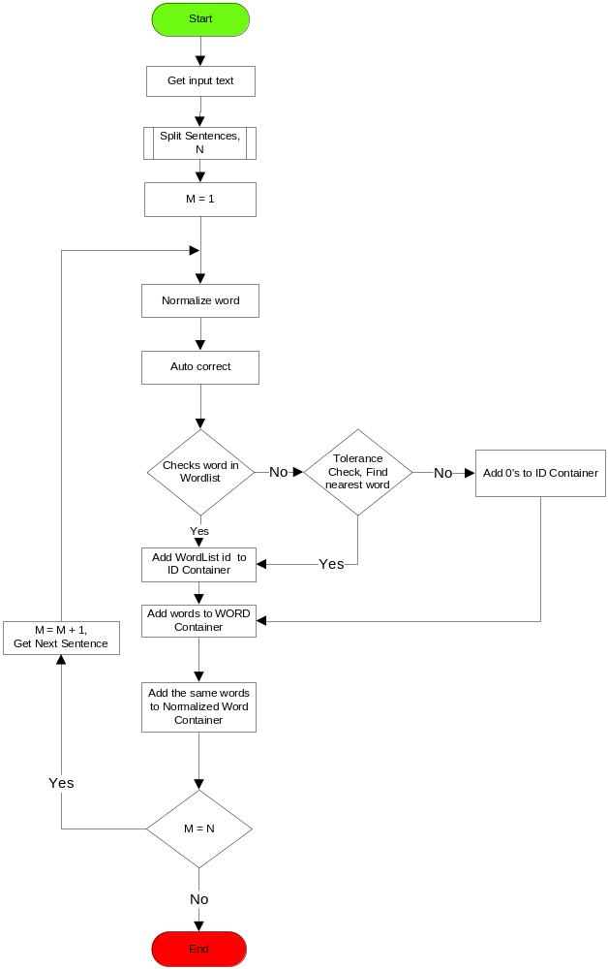
Figure 9: Work Flow – Process Sentences

Operations
NA

Inputs
User input on which pre-processing, if any, has been performed.

Information Requirements
E-SRS [87]
The VA engine should be able to identify the number of sentences in user input. For the English language, a sentence terminator can be one of the following:
- “.” Care should be taken that it is a full stop and not a decimal point or part of an email id or a web address.
- “?”
- “!”
- End of line or a new line character, provided it is the last character of the input.
- None of the above, but the user input has ended.
E-SRS [88]
- For each word in each sentence the VA engine should try and find as many words it can recognise, i.e. it is part of it’s vocabulary. For this to happen, each word in each of sentence(s) of user input is categorised into 3 containers/lists.
- The 1st container should contain the user input word as it is i.e. the raw word container.
- The VA engine should then try to normalise the word. To normalise the word, VA engine should search for the same in the auto correct list or carry out intelligent processing on it to correct spelling mistakes or typing errors to create the normalised word.
- After normalisation each word, in each sentence in the user input, should be looked up in the wordlist/dictionary, maintained by it, to try and find matching words.
- On finding a particular word in the internal wordlist the VA engine should store the wordlist id of that word in the 2nd container, called as WordID container.
- If any word is not found in the wordlist, a process should be carried out to search for nearest word, if still the word could not be matched, a zero (0) should be added to the WordID container to indicate that the word did not match any word in the wordlist.
- Each word that could be normalised/corrected and even the word that could not be normalised (i.e. the raw user input word) should be added to the normalised word container, the final 3rd container.
E-SRS [89]
- There is a requirement that this entire process should be case-insensitive.

Business Actors

Normal Flow

Output
Array/list of sentences present in user input, and 3 containers/lists associated with words present in each sentence.

Use Case: Determine Condition List
It is required that sections be created which shall refer to conditions from a main/master condition list. Each section is to be represented by a section list which shall actually contain the list of references of conditions from the main condition list. Sections are set/reset by scripts and they are specific to a user interaction session, i.e. one user may be directed to conditions from 1 section list and the other may have a completely different section list.
While setting sections in the V-Builder application, the content authors also set rules on handling the section list along with the main/master condition list. Please refer Functional Specifications for details on setting sections for recognitions.
This use case describes the process involved in choosing a section list, when user input is sent to the VA engine.
Decision regarding the usage of decision trees shall also be made in this use case, however, since Decision Trees are out of scope, the flow of decision trees is depicted only pictorially and that too in gray.

Work-Flow Diagram
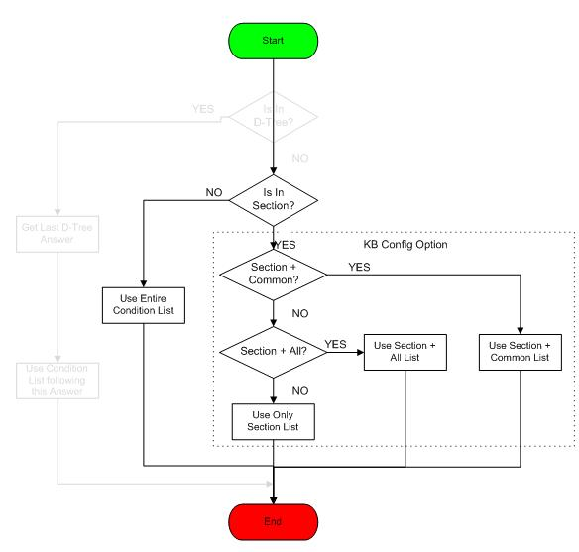
Figure 10: Work Flow – Determine Condition List

Operations
NA

Inputs
None.

Information Requirements
E-SRS [90]
- The VA engine should first check whether any section has been set for this particular transaction.
- In this scenario, the engine should first use Conditions from the Section list (the section that has been set for this transaction) and then use all other conditions from the main/master list, excluding Conditions which have already been tested as part of the first (Section-only) pass.
- If a section has been set by the scripts, one of the 3 possible scenarios, set by the content authors in the V-Builder UI, apply in determination of which type of list(s) to be used for searching:
E-SRS [91]
Identified Sectioned list and Un-sectioned (common) list:
- In this scenario, the engine should use conditions from the Section list (the section that has been set for this session) as well as conditions from the un-sectioned or the common conditions from the main/master list.
- The un-sectioned/common list basically contains those conditions that have not been assigned any section by the content authors.
E-SRS [92]
Identified Sectioned list and Fallback (main/master) list:
- In this scenario, the engine should use conditions from the Section list (the section that has been set for this session) as well as all other conditions from the main/master list.
- Conditions in the identified section list should be tested before any remaining condition from the main/master list can be tested.
E-SRS [93]
Identified Sectioned list only:
- In this scenario, the engine should use conditions from the Section list (the section that has been set for this session) only.
- This scenario shall be set only when the recognition has to be fully tied up to the context/section set by the scripts.

Business Actors
NA

Normal Flow
NA

Output
Name of the section with 1 of the 3 scenarios described above. If a section has not been set by script, the output should direct the engine to use to main/master conditions list.

Use Case: Answer Selection Process
This use case’s primary objective is to find an answer that is best suited to user’s input. Answers are associated with a recognition and each recognition can have more than 1 answer associated with it. Answers are ranked and answers with higher rank are tested before the ones with lower rank. Please refer Existing system understanding and Functional Specifications for details on creating recognitions and answers.
This use case is invoked when a condition matches a user input sentence and the associated recognition is selected. This use case describes the process for choosing answer(s) from this selected recognition.

Work-Flow Diagram
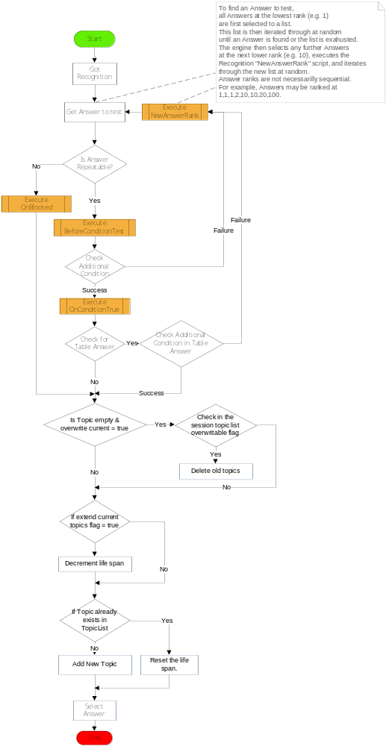
Figure 11: Work Flow – Answer Selection

Operations
NA

Inputs
The recognition selected based on the condition that matched with user input sentence. This recognition contains the associated answers.

Information Requirements
E-SRS [94]
- Each answer should be checked whether it is valid on the day of execution or not. If the answer has expired or is yet to become available, iteration should continue to the next answer in the list. An answer can be set a “Valid From” and “Valid Until” dates from the V-Builder application. Please refer Functional Specifications for more details.
E-SRS [95]
- To find an Answer to test, all Answers at the lowest rank (e.g. 1) are first selected to a list. This list is then iterated through at random until an Answer is found or the list is exhausted. The engine then selects any further Answers at the next lower rank (e.g. 10), executes the Recognition "OnNewRank" script, and iterates through the new list at random. Answer ranks are not necessarily sequential. For example, Answers may be ranked at 1,1,1,2,10,10,20,100.
- For each answer being tested, the engine should perform the following steps:
E-SRS [96]
- The following tests are not made if the Recognition rank = 0
- If the answer is ‘Repeatable’ further processing should be carried out otherwise the next answer should be tested. Please refer Existing system understanding and Functional Specifications for details on setting the ‘Repeatable’ flag.
- If the answer cannot be repeated, engine should execute the script OnBlocked, associated with that particular answer
E-SRS [97]
- In case there is only 1 answer or if there are no more answers, the use case should terminate and control should go back to the use case recognition selection for searching for some other condition that can match user input sentence.
E-SRS [98]
- If the Recognition rank = 0 or the answer is repeatable, the additional condition associated with this answer should be tested. The process of testing additional conditions is same as testing a condition from the main/master general condition list.
- Before testing the additional condition, the engine should execute the script BeforeConditionTest associated with this particular answer.
E-SRS [99]
- If the additional condition returns success, the script OnConditionTrue should be executed. This script indicates that an answers additional condition tested successfully a kind of a minor milestone in answer selection.
E-SRS [100]
- Table answer lookup should be performed for conditions of all rank, including rank 0 conditions.
- If the Additional condition evaluates to true, or there is no additional condition for this answer, the engine should check if this answer has any table answer associated with it or not. In case the additional condition evaluates to false, iteration should continue with other answers in the list.
- If a table answer is associated with it, each additional condition, the key of the table answer, should be tested with the entire user input sentence to check whether the condition is found in the sentence or not. It is required that the engine store the result of testing this table answer separately. This result should be used, instead of checking the table answer again, if any other answer(s) also refers to the same table answer for the same sentence.
- If any condition in the table answer evaluates to true the values associated with that condition should be used as the answer text. Please refer Existing system understanding and Functional Specifications for details on adding table answers to an answer and the structure of the table answers file.
E-SRS [101]
- At any point, in this use case, before moving on to check for an answer with a lower rank the script NewAnswerRank associated with that recognition should be executed.
E-SRS [102]
- After choosing an answer, the engine should manage topics as described below: (Please refer Existing system understanding and Functional Specifications for details on setting the options for topic(s) for an answer)
E-SRS [103]
- If this answer has any topic(s), the VA engine should iterate through the current session’s topics list
- For each topic in the session’s current topic list, the engine should check if that topic can be over-written by any other topic, even if it’s lifespan is not over.
- If it can be ‘overwritten’, the topic should be deleted from current the session’s topic list.
- If it cannot be ‘overwritten’, the topic should be left as it is in the list.
- The engine should iterate through the current session’s list and for each topic in the list it should check if that topic’s life span can be extended.
- If so, the topic should be left as it is and iteration should move on to the next topic.
- In case that topic’s life span cannot be extended, it’s lifespan should be decremented by 1.
- If it’s life span becomes 0 (zero), that topic should be removed from the list.
- Finally, for the topic(s), associated with this answer, check if the current session’s topic list already has this topic, if so, reset it’s life span to the value associated with this answer’s topic.
- In case the topic(s) are not present in the current session’s topic list, the topic(s) should be added to the list.

Business Actors
NA

Normal Flow
NA

Output
Selected Answer text, if an answer could not be selected the use case returns nothing.

Use Case: Create Response
Each answer that is given to the user is sent using a template defined for that particular answer. Templates are HTML/XML files that define a VA’s Web parameters, such as the background colour and title of its Web page or the font colour of its text, whether the answer should be shown in a frame or in the parent of the user’s browser window, etc.
Please refer Existing system understanding and Functional Specifications for details on setting the template for an answer.

Work-Flow Diagram

Operations
HTML templates, for all answers, should be loaded into memory at the time of loading the knowledgebase XML file. At the time of formatting the answer, the template associated with an answer should be referred from the ones loaded into memory.

Inputs
Answer text of the answer that has been selected to be sent to the user.

Information Requirements
E-SRS [104]
For the answer that has been chosen to be sent, the associated emotion image file path name should be added to the response HTML so that the user can see the emotion associated with the answer.
E-SRS [105]
- In the answer that has been chosen to be the best answer, all script expressions should be replaced by the actual values of those variables. Script variables might have been added to the answer text by the content authors to allow the user to have some meaningful/live conversation with the engine.
- It is required that at this point, all script variables in ETVs should also be evaluated.
- For e.g. the selected answer may contain the string
“${math_1} ${math_op} ${math_2} equals ${math_answer}”.
The VA engine should get the values of the script variables math_1, math_op, match_2 and match_answer and replace them in the script in place of the names. So on completion of this step the answer may look like
“4 * 5 equals 20”.
E-SRS [106]
- In the answer text, Content authors can also add, JavaScript code to enhance user’s experience of conversation with the engine. In such cases the VA engine should check whether the user’s browser supports JavaScript or not.
- If the user’s browser supports the engine should let the answer pass as it is.
- In case the user browser does not support JavaScript, the link mentioned inside JavaScript HTML tags should be replaced by simple HTML tag like <a href=””></a>.
E-SRS [107]
- If the answer has a template defined for it, the engine should look up for the same from the ones already loaded into memory, at the time of initialisation.
- If a template has not been defined for this answer, the standard template should be used.
E-SRS [108]
- In the answer text, Content authors can also add pseudo tags <nav> and <ask>. These tags will be parsed by the V-Builder and replaced by appropriate HTML tags in the published knowledgebase. Details for both the pseudo tags are given below:
<nav>
The answer text may contain <nav:http://www.google.com>click here</nav> which should have been replaced by the V-Builder as described below:
<a href = “http://www.google.com” onClick=”jsfunc(”http://www.google.com”)>click here</a>
<ask>
The V-Builder should replace the <ask:yes>Yes please</ask> with the text as shown below:
<a href="${_root}?entry=yes&ident=${_sessionid}&userlogin=${_transactionid}" onClick="jsfunc("${_root}?entry=yes&ident=${_sessionid}&userlogin=${_transactionid}")">Yes Please</a>

E-SRS [109]
- Based on the template defined, various script expressions/Template Variables, in the template should be replaced with their actual run time values.
- For an HTML template:
<input type="hidden" name="userlogid" value="%USERLOGID%" />, here USERLOGID, should be replaced with it’s actual run time value.
<td rowspan="2" valign="bottom"><img src="%IMAGEURL%%BOTIMAGE%" alt="" style="border:0; margin-left:25px;"/></td>/>, here IMAGEURL and BOTIMAGES, should be replaced with it’s actual run time value.
<td valign="bottom">%BOTANSWER%</td>, here BOTANSWER should be replaced with the actual answer text associated with this answer.
- For XML template:
<faqitems>
<breadcrumb><![CDATA[%BREADCRUMBSTRING%]]></breadcrumb>
<dropdown><![CDATA[%DROPDOWN%]]></dropdown>
<faqlist><![CDATA[%FAQLIST%]]></faqlist>
</faqitems>
Here, BREADCRUMBSTRING, DROPDOWN and FAQLIST should be replaced with actual run time values.
Similarly, in <botanswer><![CDATA[%BOTANSWER%]]></botanswer>, BOTANSWER should be replaced with the actual answer text associated with this answer.

Business Actors
NA

Normal Flow
NA

Output
Answer text formatted using the selected HTML/XML template.

Use Case: FAQ Handling
To enhance user’s experience of talking with the VA, it might be required to show an optional list of FAQ’s associated with the question asked by the user and the answer given by the VA.
FAQ’s are managed by the client and the authoring team in a Microsoft excel spreadsheet called as “Master Spreadsheet” (MSS). The MSS is synchronised with the Knowledgebase, and as a part of this process FAQ Answers have their OnChosen script updated in order to set the appropriate Category for displaying the related FAQs. The FAQ’s and their hierarchical structure are also stored in a database as part of the same MSS processing.
Care should be taken not to confuse the FAQ hierarchy (stored in a database and displayed in the template as shown in Figure 12) with the FAQ import facility. On importing FAQ-xml, new recognitions are created semi-automatically. Each FAQ question-answer pair becomes a recognition-answer pair. Please refer Existing system understanding and Functional Specifications for details on importing FAQs into the Knowledgebase.

Work-Flow Diagram
NA

Operations
FAQs are to be shown to the user based on certain keywords identified from user’s input. FAQs are to be shown to the user in 2 scenarios;
- Based on recognition of user input.
- Based on user selection of any FAQ shown on the user browser.
This use case describes requirements for handling of FAQs for both scenarios.

Inputs
The inputs are either the text typed by the user, or the Recognition and Answer numbers submitted when the user clicks on an FAQ.

Information Requirements
- FAQ handling based on recognition of user input.
E-SRS [110]
- When the user sends any input sentence(s) it is identified as a NORMAL request mode. Recognition selection takes place and an answer is identified.
- If the selected recognition is controlled by the external Microsoft Excel Spreadsheet (see above), the script OnChosen, for the answer chosen, will set the appropriate Category for displaying the related FAQs. Functions called at the end of the Recognition process get the FAQ list from database and set the value of the Extra Template variables BREADCRUMB, DROPDOWN and FAQLIST.
- These variables are replaced by their actual values in the template to be used for the answer in the use case Create Response. These values are shown to the user as part of a FAQ list that might be related to context in which the user is trying to converse with the user. These details are shown to the user as shown in the figure below:
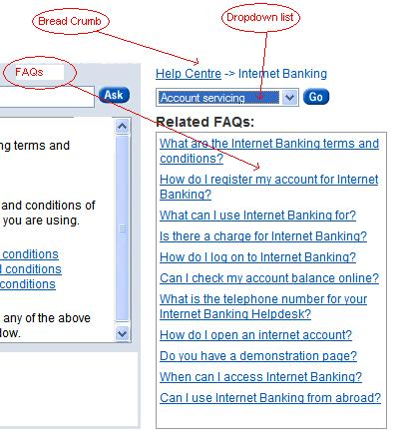
Figure 12: Various components of FAQs
- Here FAQs are shown as links to their answers or more FAQs. Each FAQ refers to another set of FAQs and the link used in the HTML tag should be the answer number of the answer that should be shown to the user when the user clicks on a particular FAQ.
For more details for handling Breadcrumbs, Dropdown, FAQlist, please refer the document given below:

- FAQ handling based on user selection of any FAQ shown on the user browser.
E-SRS [111]
- In case the user selects/clicks on the bread crumb, drop down or any of the FAQ, corresponding data is to be set to the engine using the FORM VARIABLES with the FAQ form variable.
- For this type of selection of FAQ, the parameter present in the FORM VARIABLES, should be FAQ as the user is not sending any input but has selected something from the FAQ section.
E-SRS [112]
- Along with the FAQ type, the selected Answer and Recognition numbers should also be sent to the engine.
- On receipt of the same, the engine identifies that the user has requested for a specific FAQ out of the many shown on the browser screen and bypasses the normal recognition selection process and fetches the request Recognition and answer directly.
- Before sending the answer to the user, the script OnGiven, for that particular answer, should set the appropriate Category as described above. The BREADCRUMB, DROPDOWN and FAQLIST Extra Template Variables are then set by calling functions at the end of the recognition process (as previously outlined).
- These Extra Template Variables are replaced by their actual values in the template to be used for the answer in the use case Create Response. These values are shown to the user as part of a FAQ list that might be related to context in which the user is trying to converse with the user. These details are shown to the user as shown in the figure above.

Business Actors
NA

Normal Flow
NA

Output
The FAQ list associated with this answer.

Use Case: Write VA Conversation Statistics (BOTSTATS)
It is required that at the end of a conversation, before sending the reply to the user, information related to the conversation should be stored in a log file/database, currently called as the BOTSTATS.

Work-Flow Diagram
NA

Operations
NA

Inputs
NA

Information Requirements
E-SRS [113]
- For each session, it is required that following information related to a session should be logged by the engine;
- SessionID
- IP address of the user
- Number of inputs sent by the user, including this one, the Transaction Count
- Information whether the user is of type Admin
- Information whether JavaScript is enabled on the users browser or not
- Host Name of the users machine
- Start Time of the current conversation(transaction)
- Start date of the current conversation(transaction)
- End Time of the current conversation(transaction)
- End date of the current conversation(transaction)
E-SRS [114]
- For each conversation(transaction) in each session, it is required that following information should be logged by the engine:
- Transaction id – a unique number associated with the question-answer sequence.
- The user input or the question asked by the user in this conversation.
- The response given by the VA or the answer
- Answer category
- Emotion associated with the answer given.
- Answer Number
- Answer rank
- Topic associated with the answer
- Recognition number
- Recognition rank
- Recognition sub-rank
- Whether this recognition is a FAQ or not

Critical Factors
NA

Business Actors
Engine

Normal Flow
NA

Output
Entry into the BOTSTATS file or database.

Use Case: Test V-Builder Knowledgebase
It is required that the engine should provide an interface to provide knowledge base testing facility in the V-Builder. This facility is very helpful during the creation if a knowledgebase, content authors can test the conditions/recognitions and answers created by them. They can also test the execution of scripts to simulate the behaviour of a VA as it were responding to a normal user. For details on the testing UI please refer Functional Specifications.

Work-Flow Diagram
NA

Operations
NA

Inputs
Entire knowledgebase data, control information to carry out testing.

Information Requirements
E-SRS [115]
- It is required that the VA engine should have a module which should implement and expose an interface specifically for facilitating testing for the content author. The V-Builder application should directly communicate with this module, via this interface, to carry out tests and simulate a life like question and answer scenario. For the purpose of ease of description of this use case, let’s call this module as the Test-Engine Module and the interface as the Test-Engine interface. These names are only for ease of explanation and have no other meaning or purpose.
E-SRS [116]
- It is required that the Test-Engine module should maintain/refer to the same condition list, recognition list, answer list, MACRO list, table-answers list, ETV list, topic list, system/global scripts list, Library function list - as would have been created by the use case Load Knowledgebase.
- The manner in which these lists should be created in/by the Test-Engine module is described below.
- To simulate the behaviour of the VA engine, these lists should be used in the same way as they are used for NLP by the use case Process Request and the use cases invoked by the same use case.

Loading the Knowledge base into the Test-Engine module

To receive entire knowledgebase data from the V-Builder the Test-Engine interface should provide the following functionalities:
E-SRS [117]
- Receive recognition(s) details from the V-Builder. Here, the V-Builder shall pass information about one or more newly created or updated recognition(s). Recognitions should be uniquely identified by the recognition number, created by the V-Builder.
- Whenever recognition(s) is/are sent by the V-Builder, entire information contained inside the recognition is also sent along.
- If the V-Builder sends information for a newly created recognition, and all lists have been created earlier, the Test-Engine module should check the rank of the new conditions inside this recognition and order them in the existing lists according to their rank.
E-SRS [118]
- Receive information about condition details from the V-Builder. Here, the V-Builder shall pass information about ONLY ONE newly created or updated condition within a recognition. Conditions are always associated with the recognition in which they are contained and each condition should be uniquely identified within a particular recognition by the condition number, created by the V-Builder.
- Recognitions that are blocked or not valid on the day of testing should not be sent to the engine.
- If the V-Builder sends information about a newly created condition, it should be added in the conditions list according to it’s rank. The parent recognition should also be updated about this new condition.
- If information is about an updated condition, details about it should be updated in the list.
E-SRS [119]
- Receive information about answer details from the V-Builder. Here, the V-Builder shall pass information about ONLY ONE newly created or updated answer. An answer should be uniquely identified by the answer number, created by the V-Builder.
- If the V-Builder sends information about a newly created answer, it should be added in the answer lists according to it’s rank within the parent recognition. The parent recognition should also be updated about this new answer.
E-SRS [120]
- Receive information about all Global and System scripts from the V-Builder.
- If the V-Builder sends information about a newly created script, it should be added in the scripts lists.
- If information is about an updated script, details about it should be updated in the list.
E-SRS [121]
- Receive information about all Library Functions from the V-Builder.
- If the V-Builder sends information about a newly created function, it should be added in the Library Functions lists.
- If information is about an updated function, details about it should be updated in the list.
E-SRS [122]
- Receive information about script(s) from the V-Builder. Here, the V-Builder shall pass information about ONLY ONE newly created or updated script contained within a recognition or an answer. Recognition and answer scripts are always associated with the recognition and answer, respectively, in which they are contained and each script should be uniquely identified by the script name/number within a particular recognition/answer.
- If the V-Builder sends information about a newly created script, it should be updated in the scripts lists. The parent recognition/answer should also be updated about this new script.
- If information is about an updated script, details about it should be added in the list.
E-SRS [123]
- Receive MACRO(s) details from the V-Builder. Here, the V-Builder shall pass information about one or more MACRO(s) uniquely identified by the MACRO number, created by the V-Builder.
- If the MACRO(s) already exist in the MACRO list, information should be updated else new ones should be added to the list.
E-SRS [124]
- Receive ETV details from the V-Builder. Here, the V-Builder shall pass information about one or all ETVs present to be sued for testing.
- If the ETV(s) already exist in the ETV list, information should be updated else new ones should be added to the list.

Functionality to carry out testing
A pre-requisite to carry out testing is that the updated knowledgebase data has been loaded into the data lists i.e. functionality same as the one described in the use case Load Knowledgebase has been carried out using the functionalities described above.

E-SRS [125]
- It is required that the Test-Engine module maintain session history for upto 5(configurable) transactions while testing with the content author.
- Transaction data should be maintained in a container similar to a stack with so that the most recent one can be popped out, if required.
- Whenever a new transaction takes place and it’s data is to be pushed into this stack.
- In case the number of items in the stack has already reached the maximum allowed, the oldest transaction data in the stack should be popped out, and then the latest one should be pushed in.
- Here transaction related data such as the following must be stored for each transaction, at the time of giving the answer:
- Values of all system and global variables.
- Active Topics.
- Active Section name.
- Recognition number, condition number and answer number.
- Emotion
- Analysis Category of the Answer
- Condition rank and answer rank.
- Number of conditions that were tested before selecting the one that matched.
- Value of ETVs associated with the answer.
- Values of all ETVs.
- Values of all the variables BREADCRUMB, DROPDOWN, FAQLIST.
- User input and given answer text
- Form variables associated with that transaction.
- Answer numbers for the expected responses, if any.
E-SRS [126]
- When the content author writes anything in the Test dialog box and send the same to the Test-Engine module for testing, the use case Process Request should be invoked to carry out NLP.
- The only difference in the testing mode and the normal mode should be that the use case License Management should NOT be invoked, everything else remains the same.
E-SRS [127]
- With every answer that shall be given by the Test-Engine module to the V-Builder, the Test-Engine module should always send the following:
- Names and values of all system and global variables.
- Active topics and current lifespan values.
- Emotion, Analysis category, Answer number and rank of the answer given.
- Active Section name.
- Selected Condition rank.
- Number of conditions that were tested before selecting the one that matched.
- Value of ETVs associated with the answer.
E-SRS [128]
- It is required to provide the following value-setting functionalities to the V-Builder/content authors:
- Accepting and setting a value for any of the system and global variables.
- Set life span of already active topics.
- Set new topics in the active topic list.
- Set a new value for an ETV associated with the answer.
E-SRS [129]
- It is required to provide the V-Builder/content authors the facility to set as many FORM VARIABLEs sent by the Vi-Builder and corresponding value associated with it.
E-SRS [130]
- It is required to provide the V-Builder/content authors the facility to roll back to the ‘previous’ question state.
- To roll back to the previous question-answer state, the most recent session data held in session stack should be popped out.
E-SRS [131]
- It is required to provide the V-Builder/content authors the facility to reset the transaction history and reset values of system and global variables.
- To do the same, the session stack should be cleared and all session and global variables should be reset.
E-SRS [132]
- It is required to provide the V-Builder/content authors the facility to restore the session stack with transaction data related to the transaction one prior to the most recent transaction in the stack.
- To do the same, the Test-Engine module should save this transaction data when the current test session is closed.
E-SRS [133]
- It is required to provide the V-Builder/content authors the facility to test an individual condition.
- To do this, the Test-Engine module should provide a facility to accept the condition number that should be tested and then carry out the condition test of that condition by testing it’s respective condition tree available in the master/main condition list.
E-SRS [134]
- It is required to provide the V-Builder/content authors the facility to test an individual script.
- For this functionality, the Test-Engine module should provide a facility to accept the script name along with it’s scope and number inside that scope, if it a recognition or an answer script.

Critical Factors

Business Actors
V-Builder application

Normal Flow
NA

Output
NA

NON FUNCTIONAL REQUIREMENTS
Following list of Non Functional Requirements have been identified for the new VA engine.

E-SRS-NFR [1]
Accuracy
- It is required that the response of the engine should be as accurate as possible to the answer expected for the question asked by the user. Accuracy depends on 2 major criteria:
- Creation of recognition conditions and related answers in a knowledgebase created using the V-Builder. This is a manual effort and is out of scope and impossible to control through the VA engine. For details on creating a knowledgebase, please refer Functional Specifications.
- Recognition condition searching algorithm to be implemented in the VA engine. This again is dependent on the rank given to a particular condition and to answers associated with the recognitions. If the rank is given manually, it again is out of scope of the VA engine and is impossible to control through the VA Engine.
- If the rank has been given using the automatic ranking algorithm, accuracy is dependent completely on this algorithm. Please note that this algorithm shall be given by Creative Virtual for implementation in the V-Builder.

E-SRS-NFR [2]
Timing Performance
- It is required that the entire system including the web-interface server and the VA engine deliver top performance to users input. Time taken from the moment the user’s input is received and a reply is given is dependent on the processing done to extract users input from the HTTP parameters, passing it to the VA engine, determining user type and session details, carrying out NLO activities such as condition matching, answer searching, answer formatting and finally sending the response back to the user.
- Currently these timings are not available with Creative Virtual, hence no bench marks have been set.
- However it is expected that Creative Virtual will come out with benchmarks in an Acceptance criteria document, which shall be used to match timing performance of the new engine with the older one. Timing performance comparison and analysis should be done on the basis of the criteria which should include the following:
- Number of words in the user input.
- Number of conditions tested before a match was found.
- Complexity of each condition, and the matched condition.
- Number of words in the selected answer and the kind of formatting carried out for the same.
- Number and type of scripts executed in the process
- FAQ list, if used.

E-SRS-NFR [3]
Security
- It is required that the VA engine be secure to prevent unauthorised access of data as well as execution capability. Security related requirements are detailed below:
- It is required that the knowledgebase base should be saved in XML file and the entire file should be encrypted, unless specified by an Administrator of the V-Builder. This is required so that no application other than the V-Builder and the VA engine should be able to open the knowledgebase file. Thus protecting the data from un-authorised access.
- It is required that the V-Builder should have mechanism of restriction of certain functionality/screens to users belonging to different roles. This is required to prevent un-authorised access to certain data stored within the knowledgebase file itself. Details for the same have been described in the Function Specifications.
- It is required that the scripts should be present only in the knowledgebase and should not be available as independent entities.
- It is required that the scripts should be executed only through the VA engine and also that nobody other than authorised personnel can create/modify/delete parts or whole of scripts. This is required so that any unauthorised person should not edit the script to include possibly damaging code.
- It is required that scripts (any script) should not be allowed to execute functionality code related to the Operating System.
E-SRS-NFR [4]
Availability
- It is required that entire system comprising of the web-interface server and the VA engine should be available at all times, for conversations with the user.
- The only time the VA can be unavailable is when it has been closed/shut down by an Administrator.
E-SRS-NFR [5]
Extensibility
- It is required that the application should be designed/built in such a way that any existing functionality can be extended to include new features.
- It is also required that if any framework is to be designed for the system, it should be such that new features can be easily added to the system
E-SRS-NFR [6]
Open Source
- It is required, that any 3rd party component to be used in development of the system, should be open-source and free of any licensing issues.
- It is preferred, that if any 3rd party component is to be used in any of the applications, the source code for the same should also be available.
E-SRS-NFR [7]
Platform Compatibility
- It is required that the code written for the entire system including the web-interface system and the VA engine should be platform independent and should have the ability to be executed on multiple platforms like MS Windows, Linux and UNIX.
- Any code written in C/C++ should be written in such a way that there should be minimum, preferably no change, when it has to be ported across multiple platforms.
E-SRS-NFR [8]
User Load
- Requirements for peak user load have not been specified at the time of this document.
- It is required that the web-interface server and the VA engine system should have multi- threaded architecture and the number of maximum user threads to be active at any point of time should be specified in a configuration file.
E-SRS-NFR [9]
Maintainability
- It is required that the all proposed applications i.e. the V-Builder, web-interface server and the VA engine should be designed and developed in such a manner that they are easy to maintain in the future.
- Should any need arise to modify the code for any one of the above mentioned applications, it should be possible to carry out any update or a bug-fix very easily.

ANNEXURE

Glossary of Terms
NLP
Natural Language Processing
KB
Knowledge Base
VA
The VA is a virtual interactive assistant capable of holding conversations with users in a real-time. The underlying technology is based on a sophisticated word and phrase pattern recognition system that matches pre-programmed responses in the VA’s knowledge base with question typed in by users. VA’s can be depicted graphically and can therefore express moods.
Recognition
Built on conditions
Macro
A fundamental NLP element which may consist of a complex condition, and may be used, itself, as part of a condition
Answer
Response to a user enquiry which consists of text and an emotion, as well as various answer options

Abbreviations
Abbreviation | Explanation
ETV | Extra Template Variable
V-Builder | Virtual Builder
UI | User Interface
VBSRS | Virtual Builder System Requirement Specifications
E-ERS | Engine System Requirement Specifications
KB | Knowledgebase
FS | Functional Specifications
D-Trees | Decision Trees
NFR | Non Functional Requirements

Document Describing Process for Conditions with Rank 0


